What I did …… I wanted to create a page that looked like this;
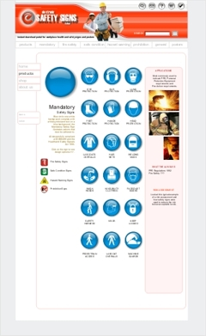
I replaced the header table in the ‘Retro’ theme with my own, keeping the tabular format exactly the same, 760px wide.

I will add a table to house my DHTML menu, haven’t done it yet, but will use Tigra (FREE), unless you know of another good menu maker ?

The body is exactly the same as ‘Retro’ original but I am trying to change the single central body into 3 columns.

The centre column is intended to stay exactly as the original body so that it can be edited in Actinic catalog.

But, the columns either side can be left for manual editing later, (unless you know a way of doing this ?????)

I changed the buttons and modified the button gifs in ‘Retro’ to my own gif’s.

I also modified Design /Options ACTSTDWIDTH variable to well narrower than the table available, but with no luck. I believe this effected ‘Separator ‘lengths ?

Col 1
Col 2
Col 3

That’s it, simple I thought ???

From Retro theme, (I backed the theme up first of course), I modified,

Act_Primary modified header table and body layout
Act_BrochurePrimary modified header only
Act_BrochurePrimaryLeft modified header only

