When you want to print from POS application here is what you get:

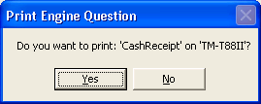

If you click on yes you get:

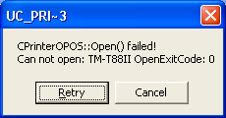

When you click on Retry nothing happens, it displays this same window.
If you click on Cancel you get:

